Launching EC2 Machine and Connecting through Browser-Based SSH

Lab Details

1. This lab walks you through the steps to launch and configure a virtual machine in the Amazon cloud.
2. You will practice using Amazon Machine Images to launch an Amazon EC2 Instances.
3. You will connect to your Instance through Browser-Based SSH.
4. AWS Region: **US East (N. Virginia) us-east-1**

Architecture Diagram

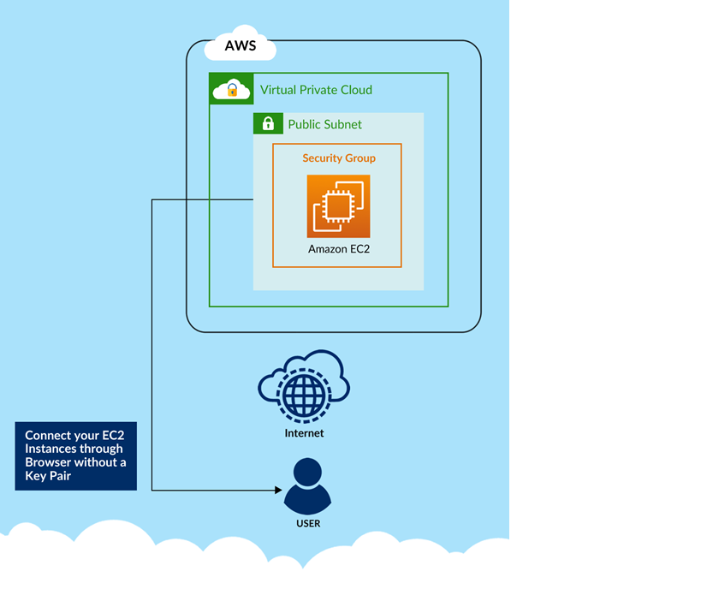

Task Details

1. Log into AWS Management Console.
2. Launch an Amazon Linux Instance from an Amazon Linux AMI 2
3. Find your instance in the AWS Management Console.
4. Connecting to your Instance through EC2 Instance Connect.
5. Validation of the lab